**Problem Statement:-**

**Convert XML File into Json File Format.**

**ANSWER:-**

For converting XML data to JSON we require org.json jar file through which we can read XML data and convert it into JSON format.

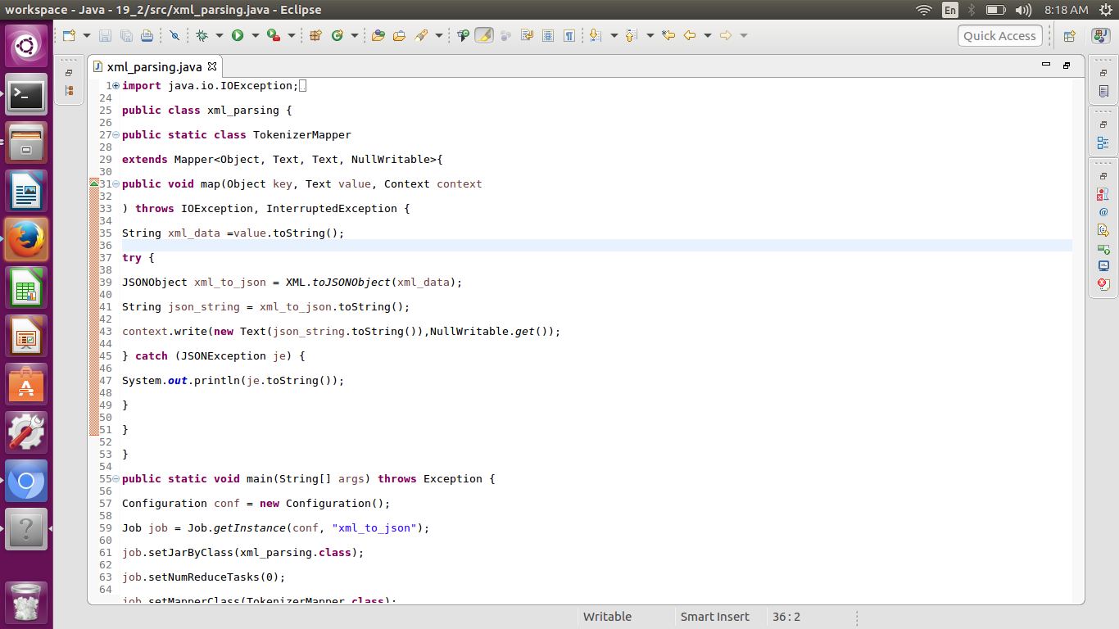

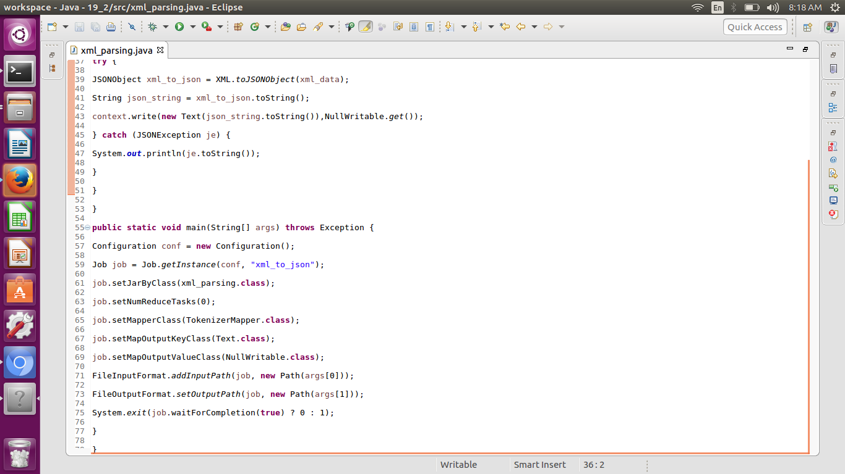

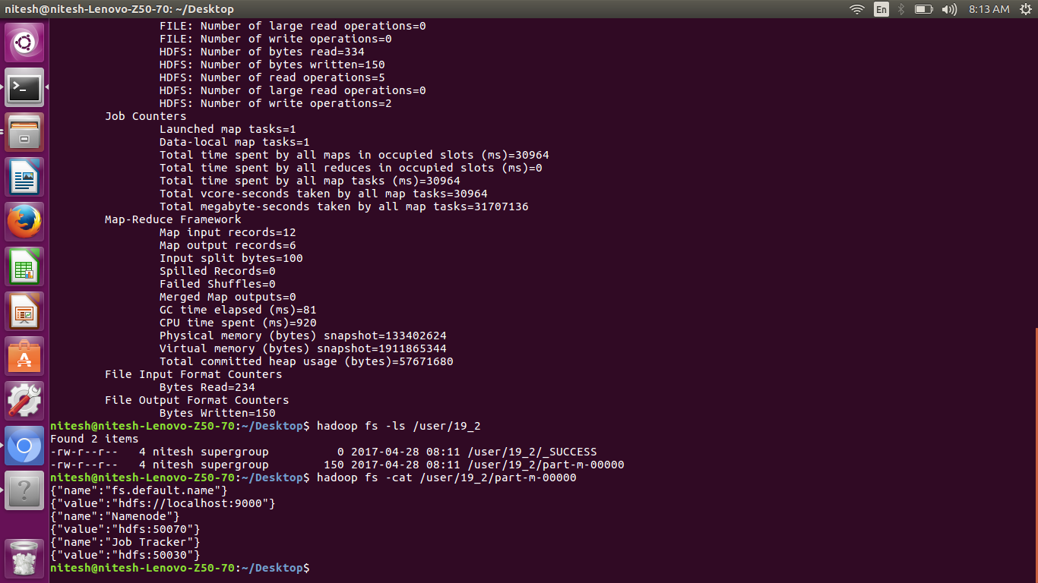

Since we are converting one format of data into another, that is we need not be processing logic so we can end up with one Map phase itself.

In the above program, the String xml_data will read an XML record and converts it into a String using the toString() method. This XML record is converted into JSON object using the XML.toJSONobject() method present in the jar file which we have added. Now, the XML record will be converted into a JSON object. The obtained JSON object will be again converted into String using the toString() method. With this our use case is completed. We need to write this converted JSON object into the context. Since we do not have any values in this program, we are making the value as NullWritable.